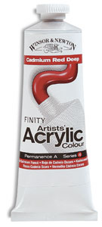
ART SUPPLIES

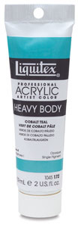
Acrylics (any brand – 37 ml. tubes or smaller)
- White
- Cadmium yellow (deep)
- Cadmium yellow (light)
- Raw sienna
- Burnt sienna
- Raw umber
- Burnt umber
- Olive green (or Hunter green)
- Cobalt light green
- Okra
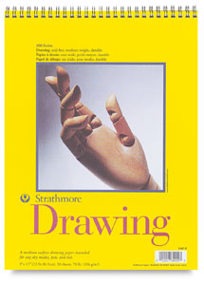
- Ultramarine blue
- Cobalt blue
- Cobalt red (deep)
- Mars black

Paper Pads
- 18” x 24” 80# (or greater)
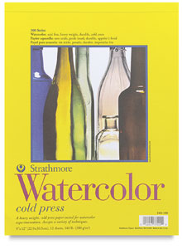

Canvas
- Canvas on frame -or –
- Canvas on board -or –
- Canvas on museum board
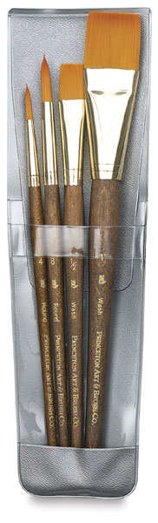

Brushes (synthetic)
- No 1 (round)
- No 2 (flat)
- No 5 (flat)
- No 10 (flat)

